You Take Control
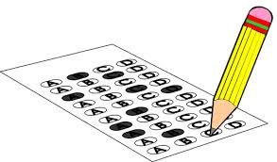
You CAN do it! Believe in YOU
Before the Test
- Think about it – Your entire future does not depend on this test
- Get Prepared – Do practice tests, additional homework, and ask questions
- Remind Yourself – Think of a time you succeeded before – you can do it again!
- Don’t forget physical preparation – Get a good night’s sleep 2 nights before, eat protein, have plenty of water, don’t eat sugary foods, and make sure you have everything you need for your exam
- Picture it – See yourself passing the test!
- Arrive prepared – Relax, remind yourself you studied hard and will do your personal best
During the Test
- Test Tips – Read directions carefully, point out important words, take deep breaths
- Calm Yourself – If you start to think negative thoughts, close your eyes and take deep breaths. Stretch your arms and legs in your seat. Tense and relax your muscles. Use positive self-talk (I CAN do it!)
- Baby Steps – Take it one step at a time. Break your test down into small parts.
After the Test
- Reward Yourself – Play a game with your family or have a special dinner. Stay positive! YOU DID IT!

Remember FOCUS
Face It – Think Positive Thoughts about the Test
Organize It – Work at a medium pace – Don’t rush! Organize your answer choices, prepare the night before
Conquer It – Lose those negative feelings and use your brain power – You got this!
Understand It – Read carefully, hear words in your mind, and find key words
Scan It – Look over your entire test. Make sure you don’t leave anything blank

